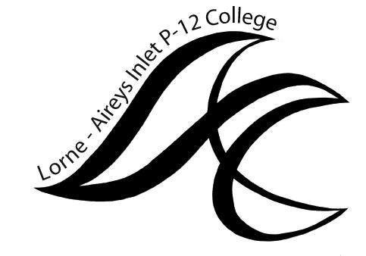LORNE P-12 COLLEGE
COLLEGE COUNCIL MEETING
MINUTES
Tuesday May 11th, 7:00pm-8:30pm

Acknowledgement of Country
We acknowledge the Gadubanud people as the Traditional Owners of the land on which we meet,
and pay our respects to elders past, present and emerging.

SPECIAL EVENT | DETAILS / DISCUSSION | ACTION
Building Program update from Haskell Architects
MEETING ITEM | DETAILS / DISCUSSION | ACTION
Apologies
Minutes of Previous Meeting | Minutes of the previous meeting to be tabled. | Motion: “That the minutes of the previous meeting be accepted.”
Business Arising
REPORTS
Principal’s Report | Report & correspondence to be tabled. | Motion: ”To accept report and correspondence as tabled”
Finance Reports |  | Motions:  ”That the financial statements for the months of March & April be ratified and all accounts approved for payment.”  “That the statements and payments as tabled for the School Purchase Cards be accepted.”  “That School Council approve the writing off charges, additional revenue/adjustments/note over/under expenditure as documented and discussed”  “That the School Council approve and endorse the budget adjustment as described”
Master Plan | Report to be tabled | Motion: ”To accept report as tabled”
Extension of meeting for 10 mins | Agreed
Student Learning | Report to be tabled | Motion: ”To accept report as tabled including the following:
Parent Club |  | Motion: ”To accept report as tabled”
Camp / Adventure Activities Approvals | No applications | Motion: ”To approve camps and activities as tabled”
Child Safe | Standing item.

GENERAL BUSINESS:
Annual Report | Tabled and discussed.
Meeting closed 8.49pm

CORRESPONDENCE IN:
DET | COVID-19 Operational Guidelines

Next Meeting: Tuesday June 15th

